**AN IMPROVED VOGEL’S APPROXIMATION METHOD FOR THE TRANSPORTATION PROBLEM**

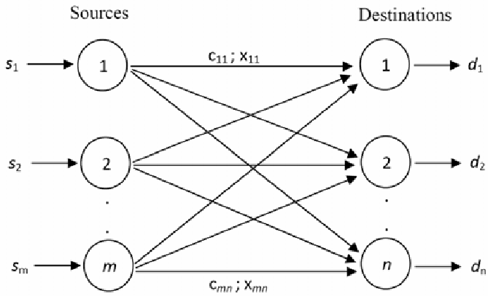

**Figure 1 : Network Model of the Transportation Problem**

**VOGEL’S APPROXIMATION METHOD (VAM) :**

In the example given below, matrix size is 5x5. S1-S5 are source points and D1-D5 are destination points. Each box in the left of the columns represents constant costs (cij) and each empty box in the right of the columns represents allocation quantities (xij), which is the number of units shipped from supply point i to demand point j.

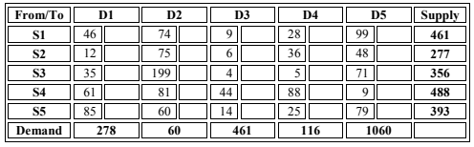

**Table 1 : An example of 5x5 transportation problem**

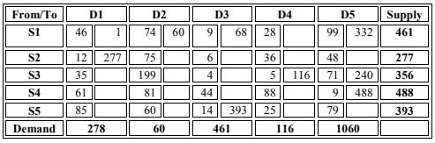

**Table 2 : Initial solution tableau for VAM**

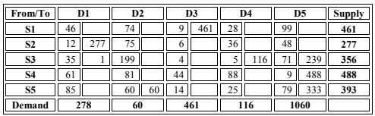

**Table 3 : Optimal solution tableau for VAM**

However, the problem with VAM is that simulation experiments showed that although it gets efficient initial solutions for small sized transportation problems, it is insufficient for large sized transportation problems. It also suffers from high total iteration numbers, CPU times and computational difficulty for the optimal solution.

**IMPROVED VAM (IVAM) :**

For the transportation problem given in Table 1, the initial solution of VAM requires five additional iterations to reach the optimal solution. On the other hand, the initial solution of IVAM is the optimal solution of the given example problem without additional iterations. Initial cost from Table 4 is 59356 and this also is the optimal value of the considered problem.

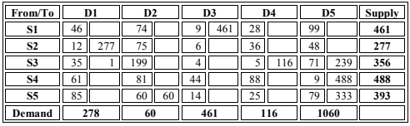

**Table 4 : Initial solution tableau for IVAM**

**Results:**

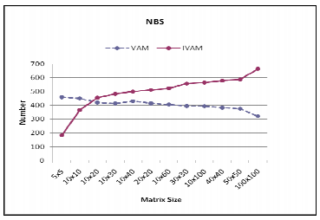

**Figure 2 : Number of best solutions**

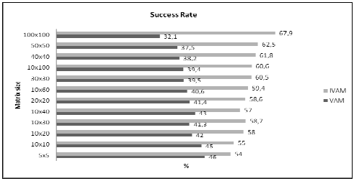

**Figure 3 : Success rate of VAM and IVAM for different sized problems**